

**CLOUD COMPUTING LAB:02**

**Submitted By:** Seerat Fatima

**Registration.no:** 2023-BSE-060

**Section: 5B**

**Submitted To:** Engr.Shoaib

**Install Git on your PC.**

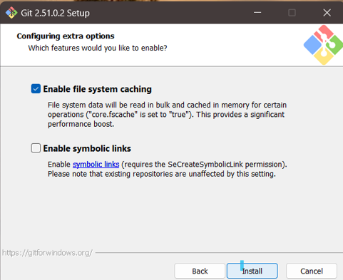

**Task 1: Create Private GitHub Repository**

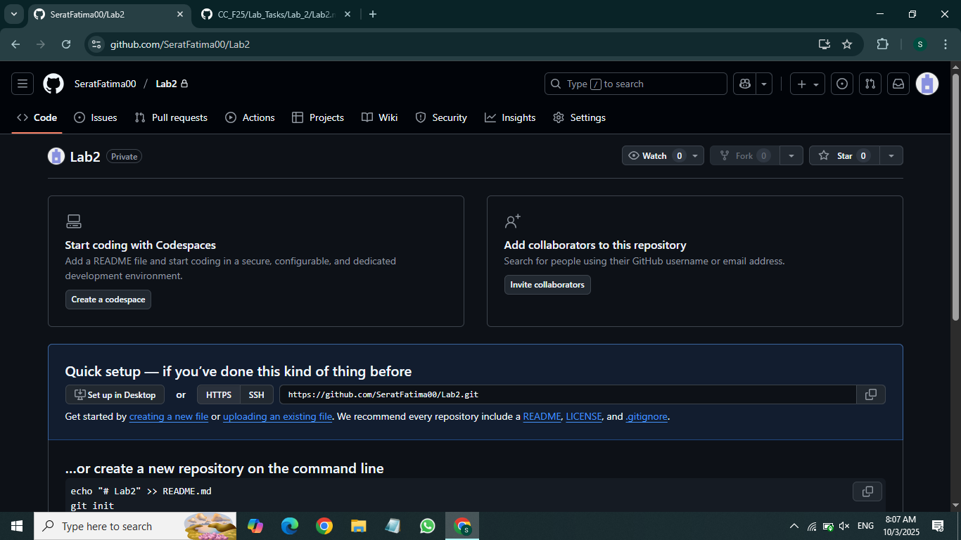

**Task 2: Connect Repository via SSH**

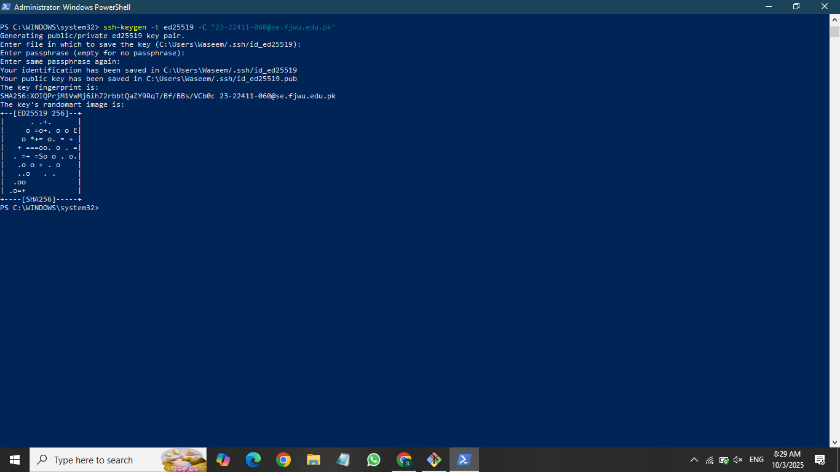

**Task 3: Configure Git Username and Email**

**Task 4: Explore the .git Folder**

**Task 5: Local Repository Management**

**Task 6: File Status & Staging**

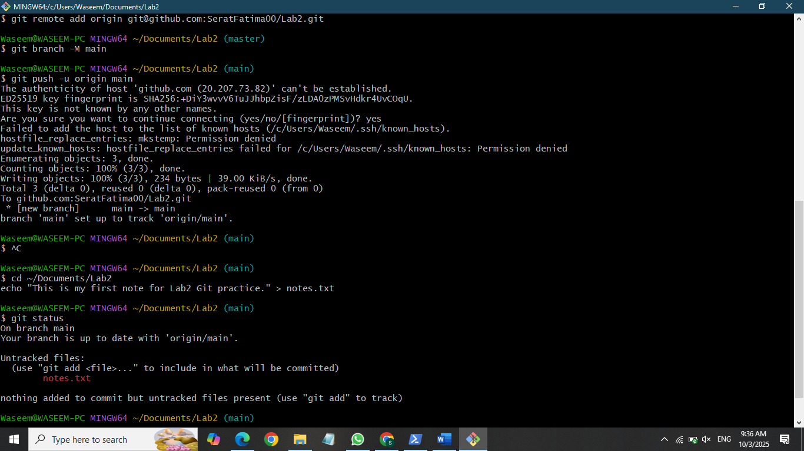

**Task 7: Branch Creation Using GitHub GUI**

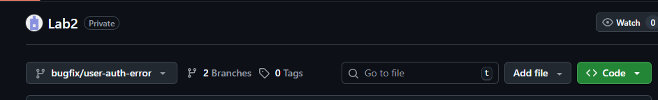

**Task 8: Branch Creation and Push Using Git Bash**

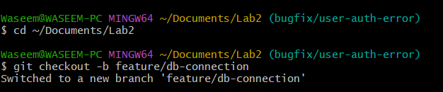

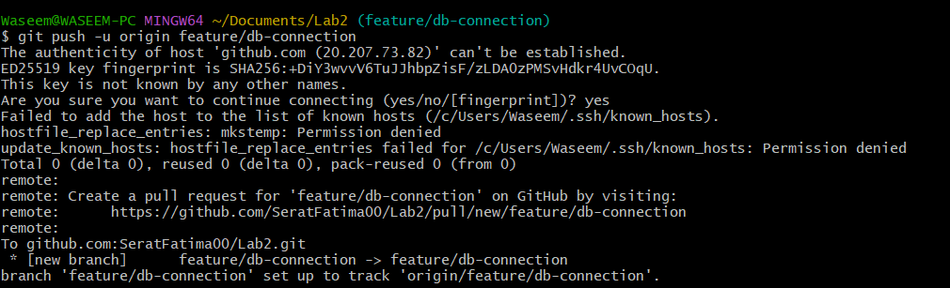

**Task 9: Branching & Merging**

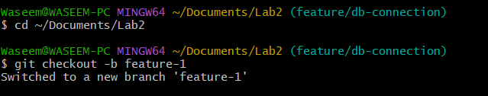

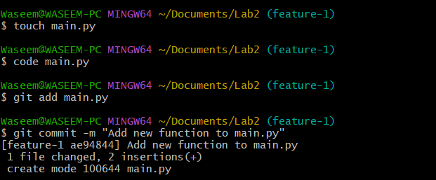

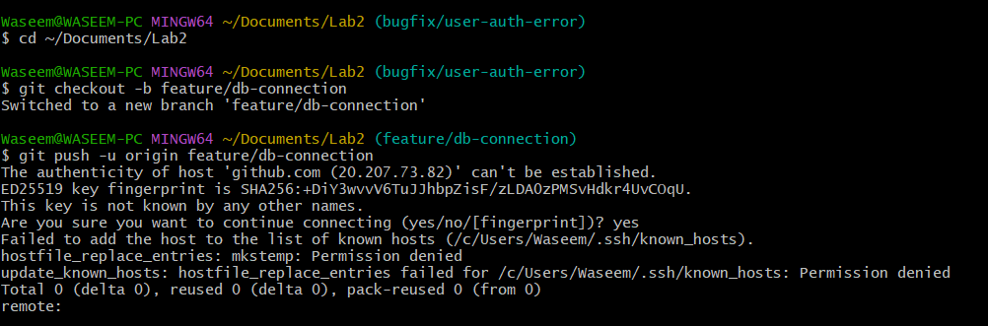

**Task 10: Pull Request and Branch Review (GitHub GUI)**

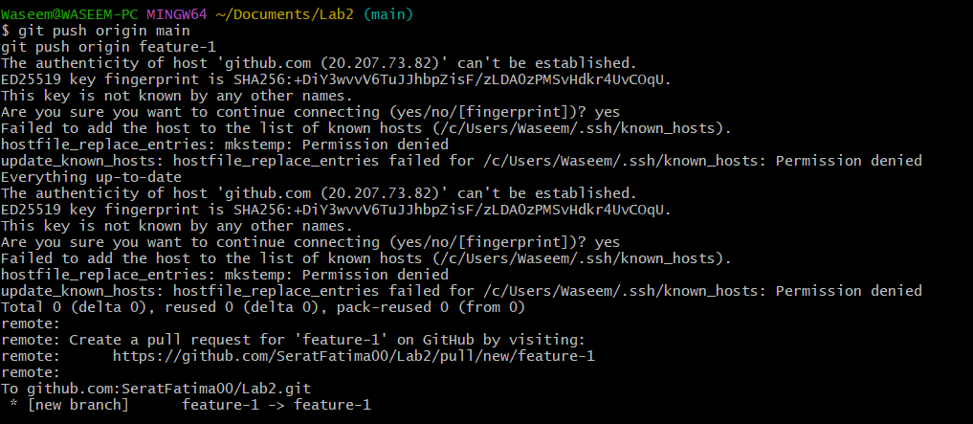

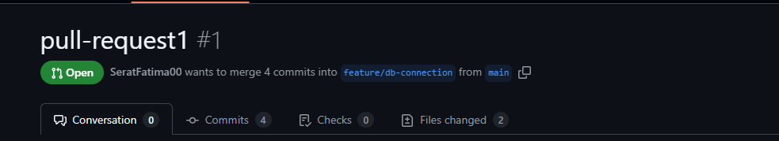

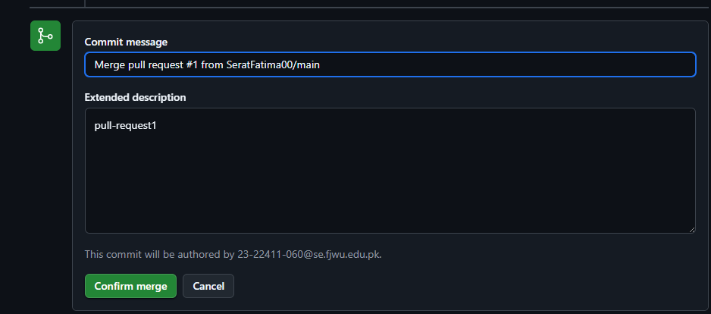



**Task 11: Detailed Branch Strategy (Develop/Staging)**

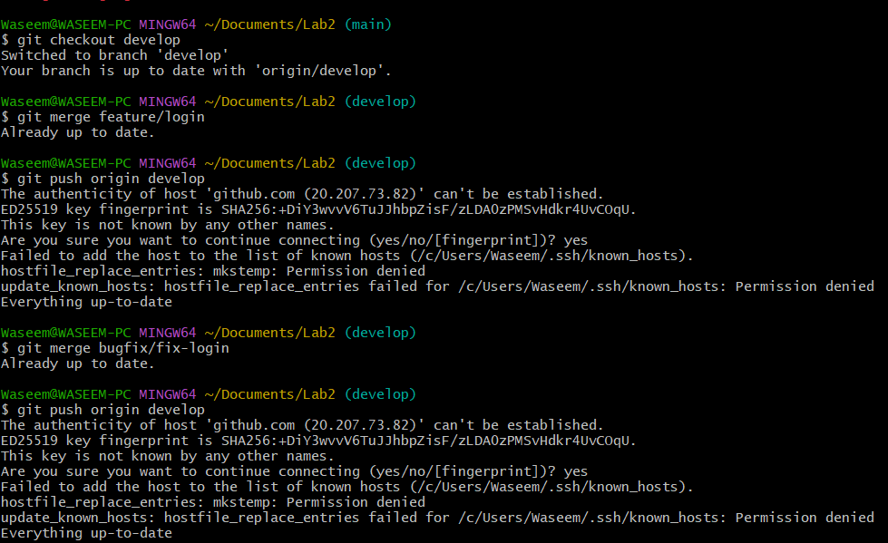

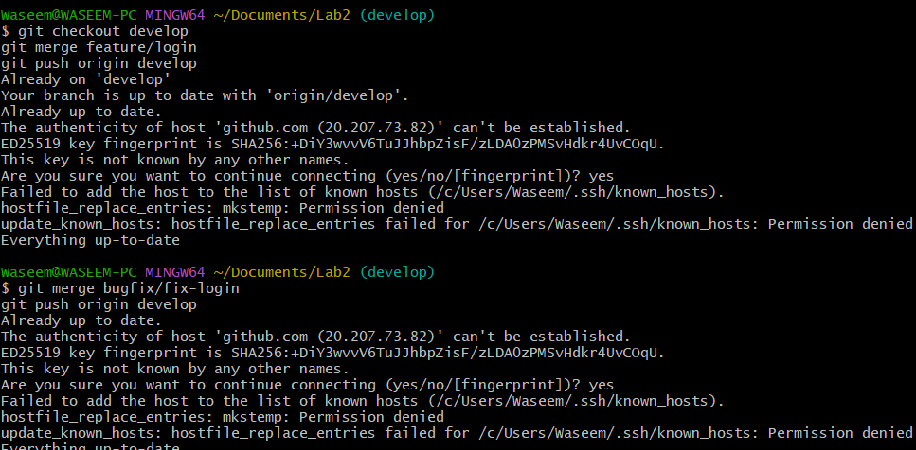

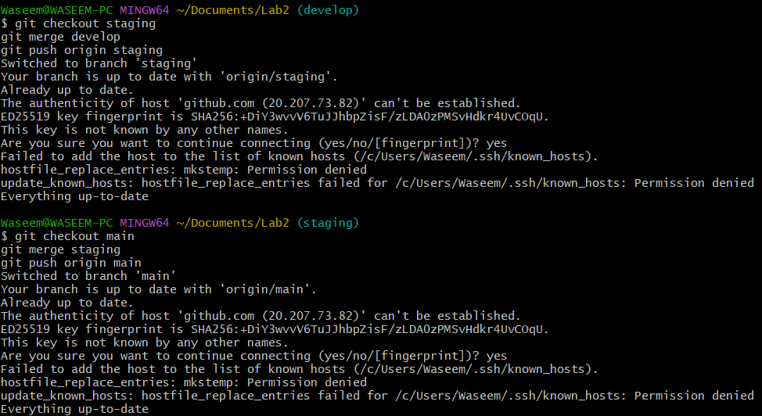

**Task 12: Code Review Workflow**

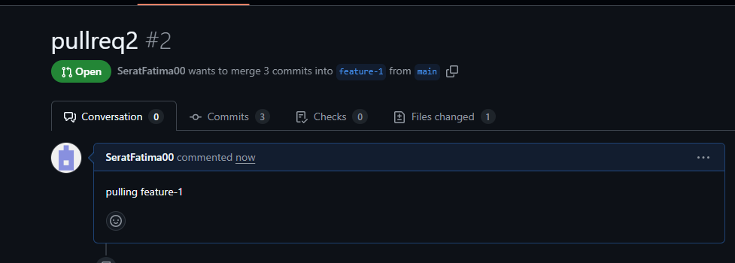

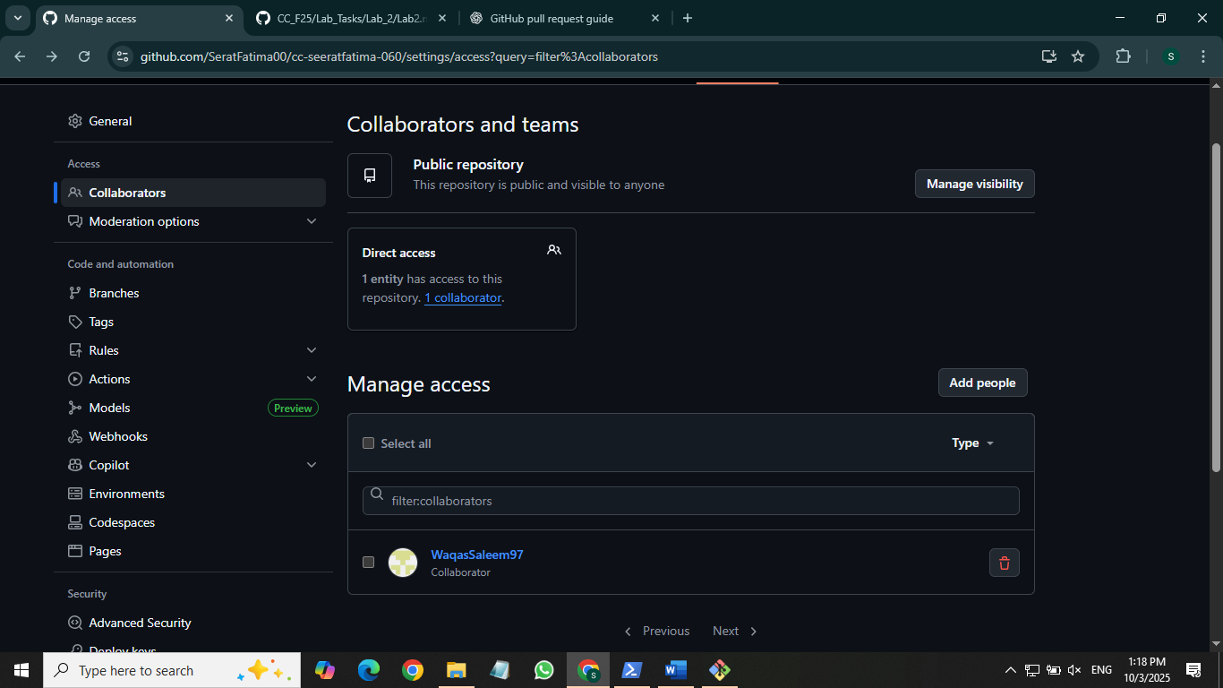

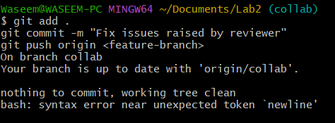

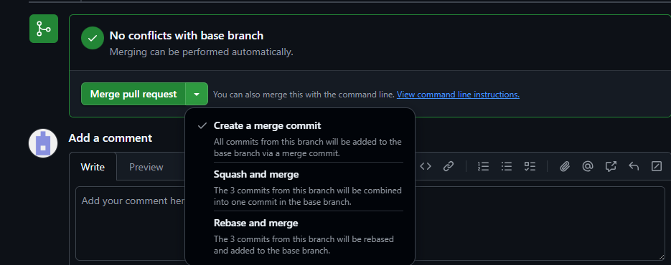

**Task 13: Branch Cleanup Best Practices**

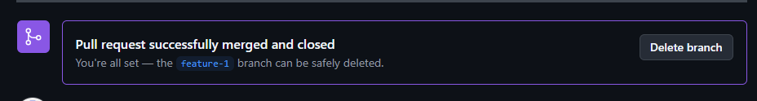

**Exam Evaluation Questions**

1. **Advanced Branching & Merge Verification**
   * **Create a new branch in your repository.**
     + **Screenshot as Q1_branch_created.png.**
   * **Make a small change in a file and commit it.**
     + **Screenshot as Q1_commit_done.png.**
   * **Merge this branch back into the main branch.**
     + **Screenshot as Q1_merge_done.png.**
   * **Show the history of commits in a way that verifies the merge.**
     + **Screenshot as Q1_merge_history.png.**

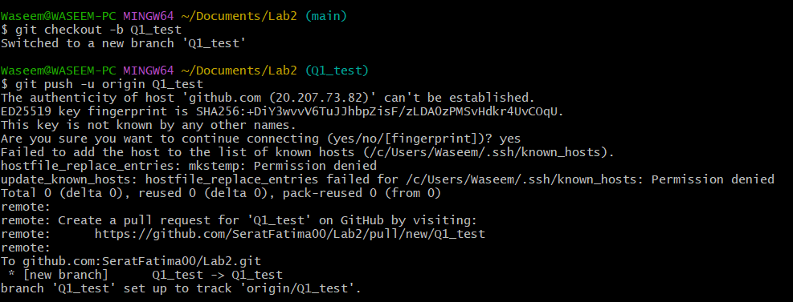

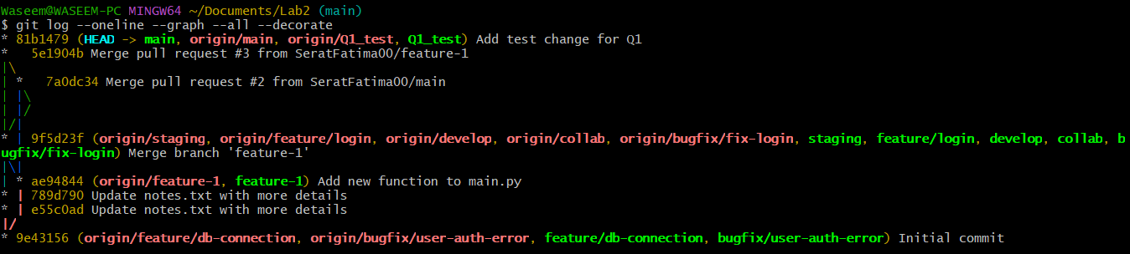

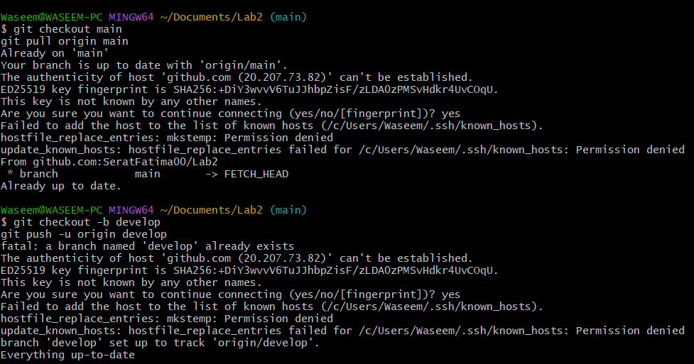

1. **Multi-Stage Workflow Simulation**

Set up a branching workflow with three branches: main, develop, and staging.

Screenshot as Q2_branches_created.png.

Create a feature branch from develop, make changes, and commit them.

Screenshot as Q2_feature_branch_commit.png.

Merge the feature branch into develop.

Screenshot as Q2_merge_into_develop.png.

Merge develop into staging.

Screenshot as Q2_merge_into_staging.png.

Merge staging into main.

Screenshot as Q2_merge_into_main.png.

Provide proof that each stage contains the updated changes before it reaches main.

Screenshot as Q2_stage_verification.png.



